How to get to Owlnet for a former employee

- Got to williamwoods.edu website
- At the top right hand of the screen click on Faculty and Staff, shown below.
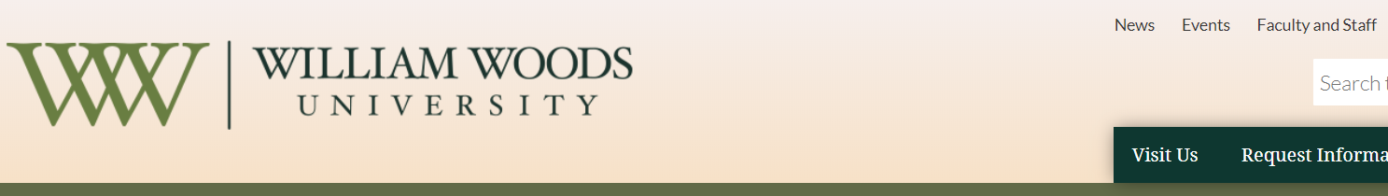

- Click on the Former Employees link on either the left or right of the screen.
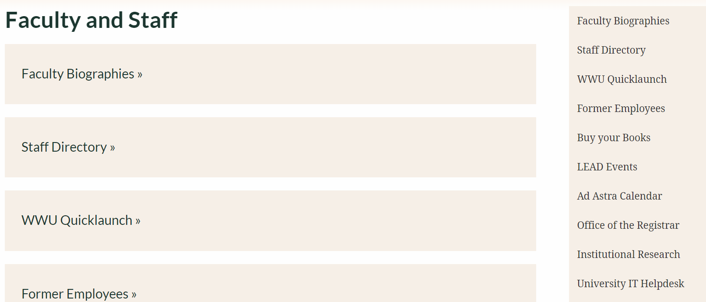

- Click on the Log In button in the center of the screen, and put in your username and password (If you do not know your password follow the instructions below the Log In Button. If you also do not remember your ID number please call the Help Desk at 573-592-4224 and we can give that information to you.)
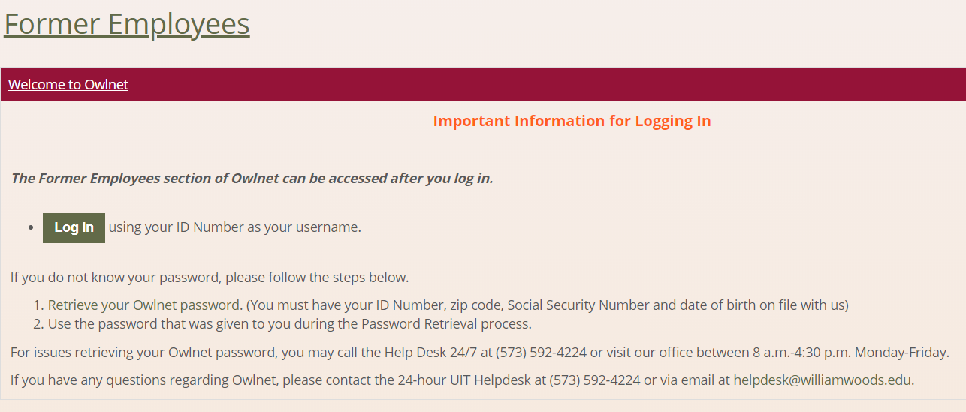

- Once logged into Owlnet you will see a person icon at the top right hand side of the screen and if you click on it will say Welcome back and your name. Next click on the Former Employees link at the top of the screen in the green banner.
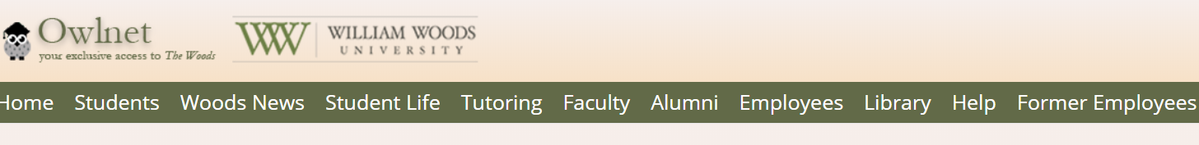

- Then scroll down and you will see links for your pay stub and tax information.

